Week 10

**Generative Modelling**

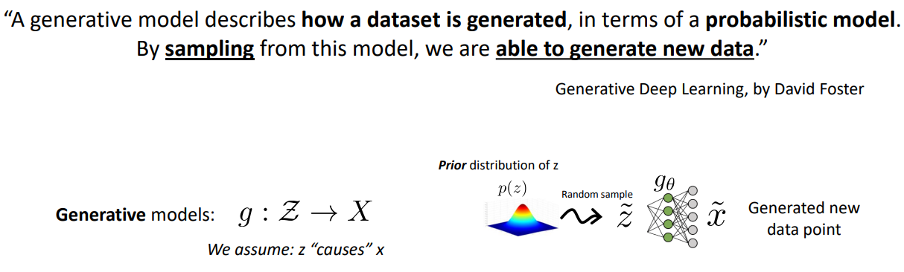

**Variational Auto Encoders**

They are just like Auto Encoders but the bottneck layer is divided into two parts.

Smaller the standard deviation, smaller the chances of uncertainty.

When SD is 0, probability is 1 which is the predicted mean. Same behavior as Auto Encoders.

SD must be positive.

SD will have low values around 0 so we can’t use ReLU.



